Common Reading Week Beginning October 30, 2023
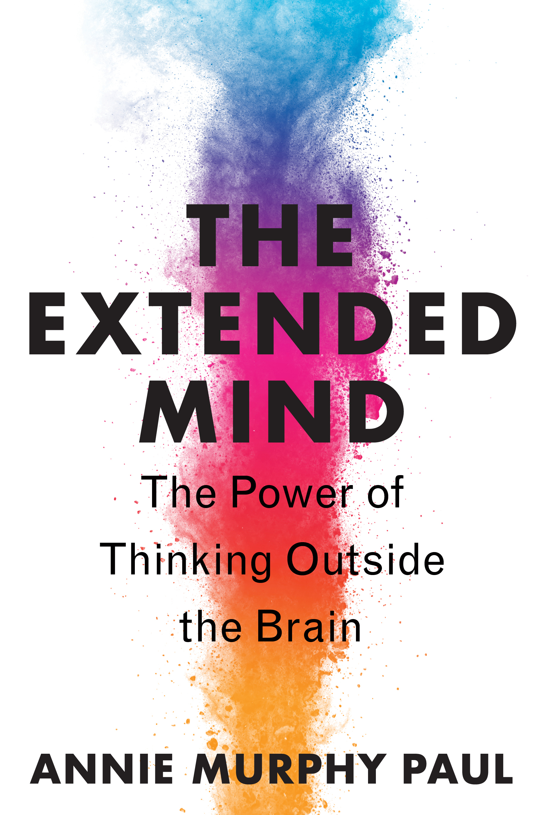 |  | Events for the 2023 Common Reading Week include:  - Monday, 10/30 “Tips and Tricks: Advising and Your Career Plan” by Michael Stella at 12:15 p.m. until 1:15 p.m. in 145 Thun  - Tuesday, 10/31 “Extending the Mind: Stress Management Techniques” presented by Autumn Fritz at 12 p.m. until 1 p.m. in The Lion’s Den (across from Tully’s)  - Wednesday, 11/1 Keynote presentation “The Extended Mind” by author Annie Murphy Paul at 12:15 p.m. until 1:15 p.m. in the Perkins Auditorium  - Thursday 11/2 Sights and Sounds of Campus WWAK, beginning at noon at the Lion Shrine, led by Dr. Colleen English; additionally, the 6th Annual Migrant Education Book Drive benefitting the Reading Area School District will end with a bilingual storytelling event within an RASD school.  - Friday 11/3, “The Extended Mind: Body Language” 12:15 p.m. to 1:15 p.m. in Thun 145.
Common Reading Week 2023 is sponsored by Barnes & Noble

